Lesson 1 – NumPy Refresher
Topic: Arrays, creation, indexing, slicing, reshaping, operations

🔹 NumPy & Arrays

Theory Notes
- NumPy = Numerical Python, a library for numerical computing.
- Main object: ndarray (n-dimensional array).
- Advantages: fast, efficient, vectorized operations.

Python lists vs NumPy Array

Practical
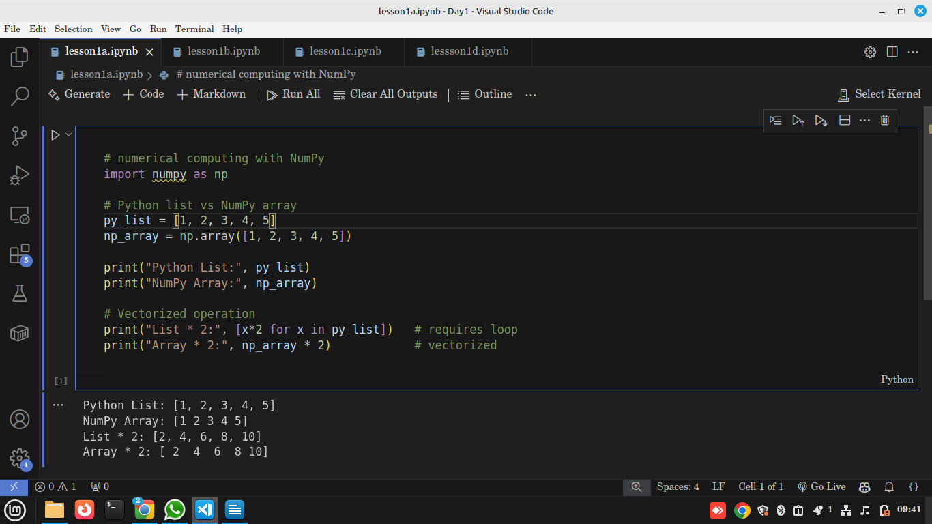

Explanation
- We imported NumPy as np (common alias).
- py_list is a normal Python list.
- np_array is a NumPy array created from the same numbers.
- When multiplying a Python list by 2 → it duplicates the list [1,2,3,4,5,1,2,3,4,5].
- When multiplying a NumPy array by 2 → it multiplies each element ([2,4,6,8,10]).
- This is the power of vectorization.

Note:
- A Python list requires a loop to multiply each element.
- A NumPy array applies the operation automatically to all elements.
- This makes NumPy much faster when working with large datasets.

Use in Data Science
NumPy arrays are the foundation of pandas DataFrames, scikit-learn, and deep learning libraries. Almost every dataset you load is converted internally into arrays for speed.

🔹 Array Creation Methods

Theory Notes
Ways to create arrays in NumPy:
- From Python lists → np.array()
- Number ranges → np.arange()
- Even spacing → np.linspace()
- Special arrays → np.zeros(), np.ones(), np.eye()
- Random arrays → np.random.rand(), np.random.randint()

Practical

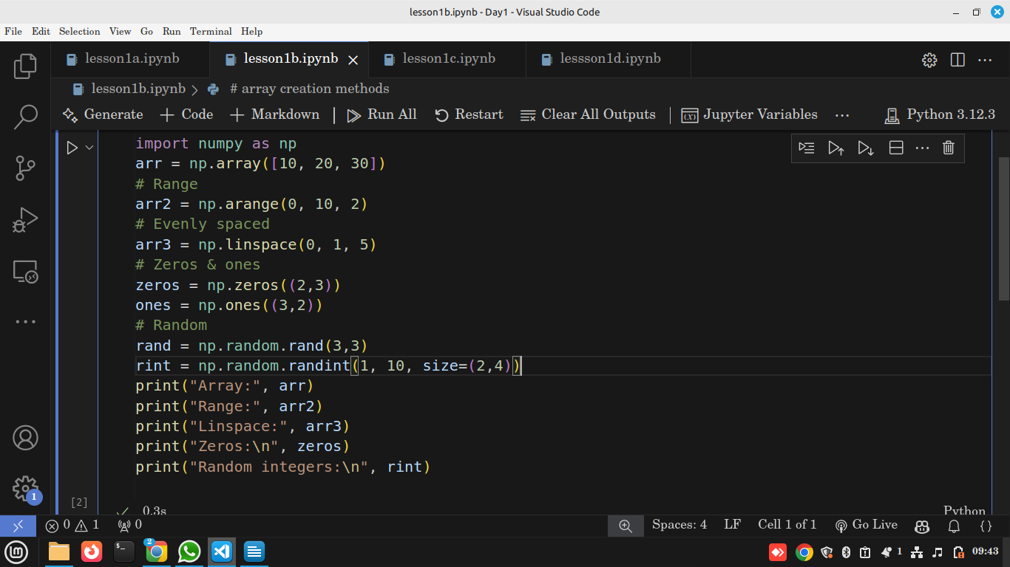

Output
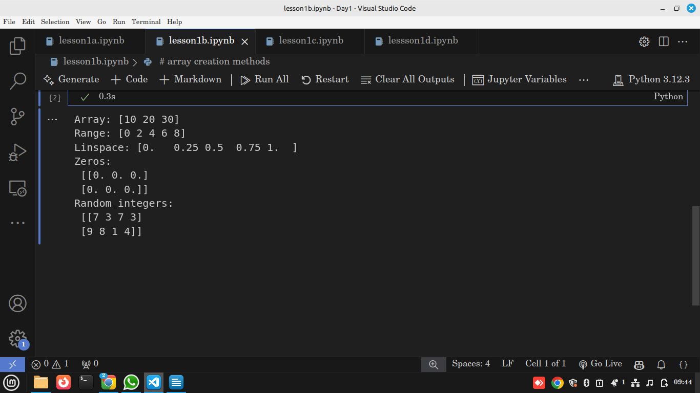

Explanation
- np.array([10,20,30]) → creates an array from a list.
- np.arange(0,10,2) → creates [0,2,4,6,8].
- np.linspace(0,1,5) → creates 5 numbers evenly spaced between 0 and 1.
- np.zeros((2,3)) → 2 rows, 3 columns, all zeros.
- np.ones((3,2)) → 3 rows, 2 columns, all ones.
- np.random.rand(3,3) → 3×3 matrix of random floats between 0–1.
- np.random.randint(1,10,size=(2,4)) → random integers 1–9 in a 2×4 grid.

Use in Data Science
- np.arange and np.linspace are used to generate sequences of features (like time steps).
- Random arrays are essential in machine learning for initializing model weights, or for creating synthetic datasets.

🔹 Indexing & Slicing

Theory Notes
- Indexing = accessing elements.
- Works in 1D and 2D arrays.
- Uses row, column notation for 2D.

Practical
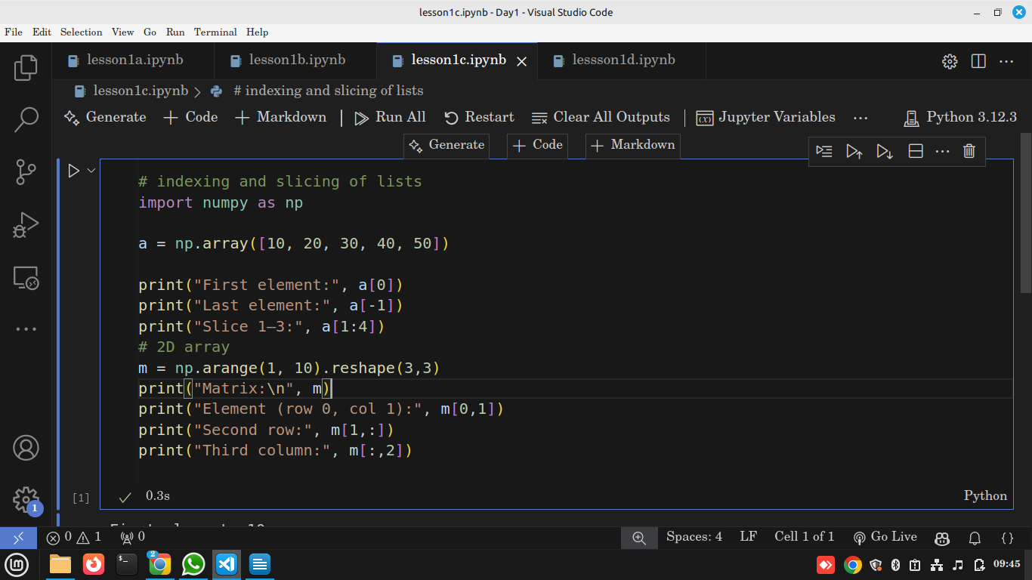

Output
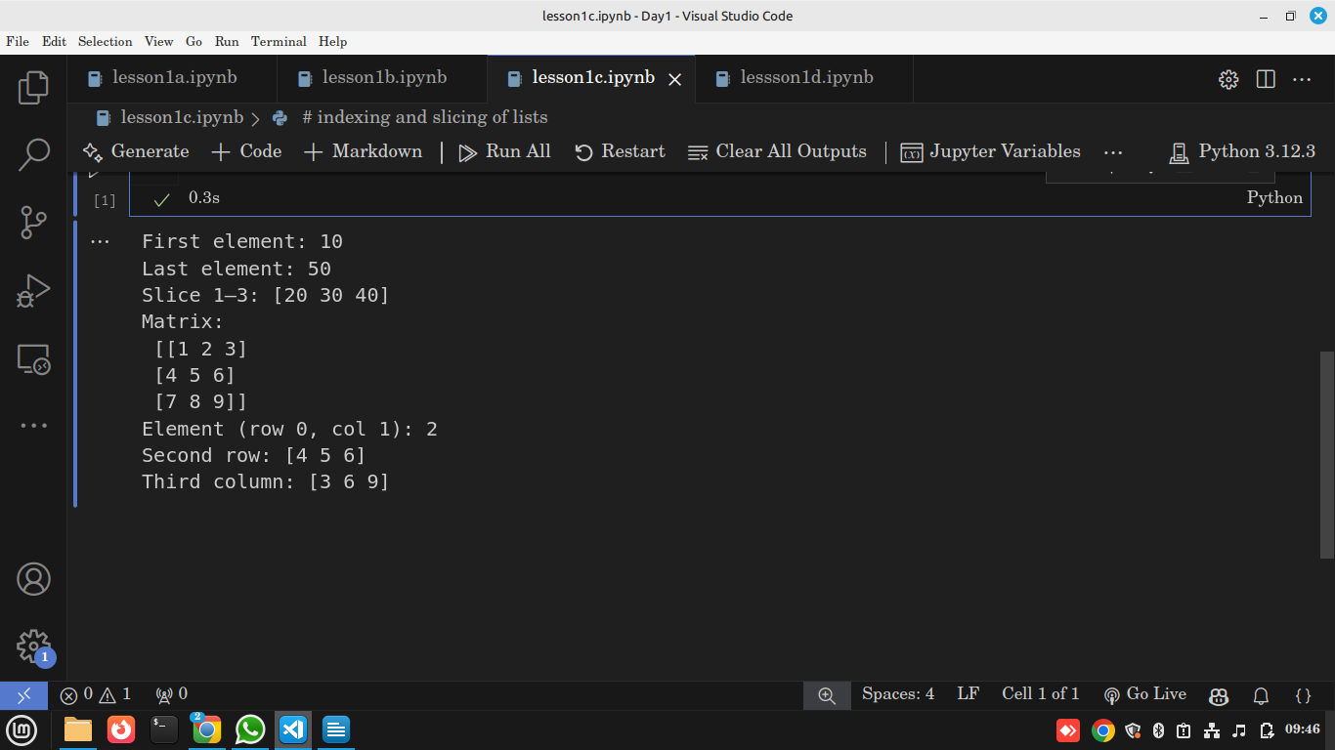

Explanation
- a[0] → gives first element 10.
- a[-1] → gives last element 50.
- a[1:4] → extracts values from index 1 to 3 → [20,30,40].
- m = np.arange(1,10).reshape(3,3) → makes a 3×3 matrix from numbers 1–9.
- m[0,1] → element in row 0, col 1 (value = 2).
- m[1,:] → entire second row [4,5,6].
- m[:,2] → entire third column [3,6,9].

Use in Data Science
Indexing and slicing are key in data wrangling. For example, selecting a column of features (like “age”) from a dataset or filtering specific rows (like “patients over 50”).

🔹 Reshaping & Operations

Theory Notes
- .reshape() changes array shape without changing data.
- .T transposes rows ↔ columns.
- Math/stat functions: .sum(), .mean(), .std(), .max(), .min().
- Arithmetic is element-wise.

Practical
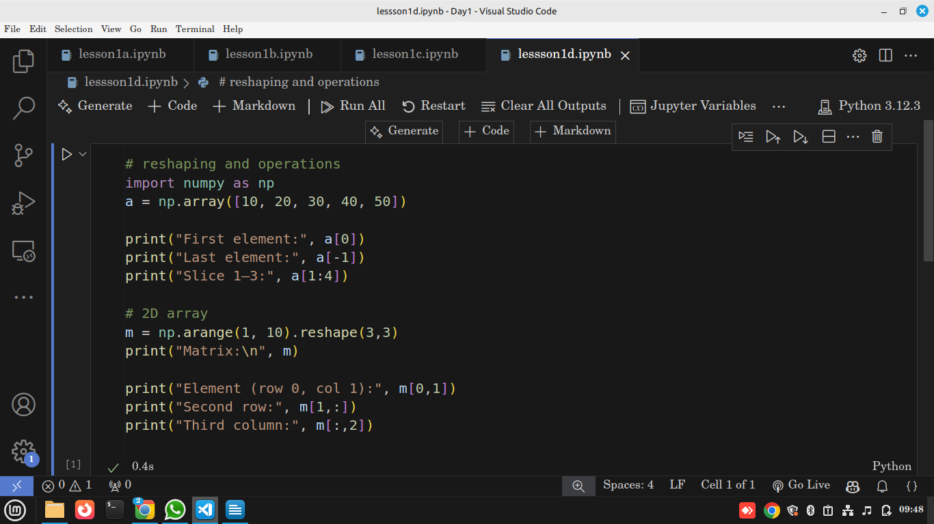

Output
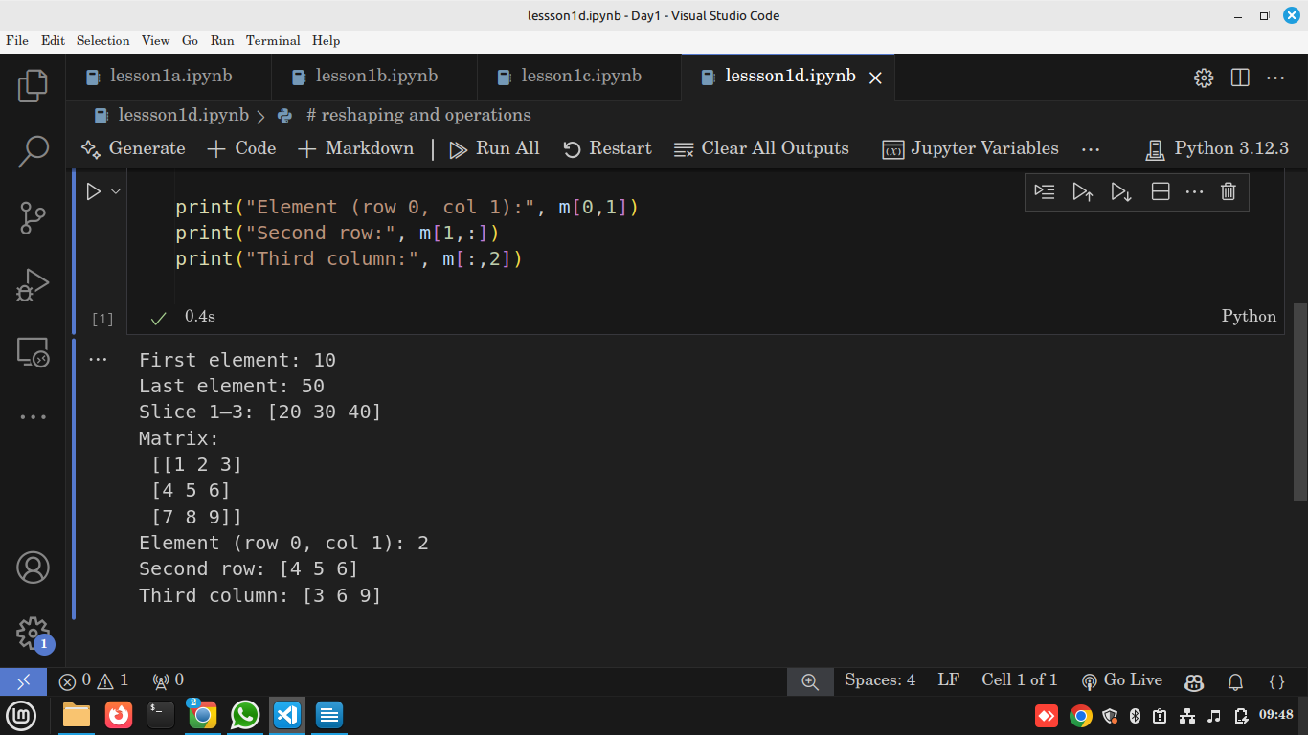

Explanation
- np.arange(1,13) → creates numbers 1–12.
- .reshape(3,4) → reshapes into 3 rows × 4 columns.
- .T → flips rows & columns.
- .sum() → adds all numbers.
- .mean() → computes average.
- .std() → measures spread (standard deviation).
- Multiplication (*2) and addition (+5) apply to every element.

Use in Data Science
Reshaping is crucial when preparing data for machine learning models, where inputs must have a fixed size (e.g., reshape images into arrays). Stats functions help quickly summarize datasets (e.g., average income, standard deviation of ages).

📝 Assignment

🔍 Reflection
Discussion on why NumPy is faster and real-world use cases.

